**Jenkins task-02**

1. Configure 2 slave machines in jenkins master.
2. Configure webhooks to jenkins job.

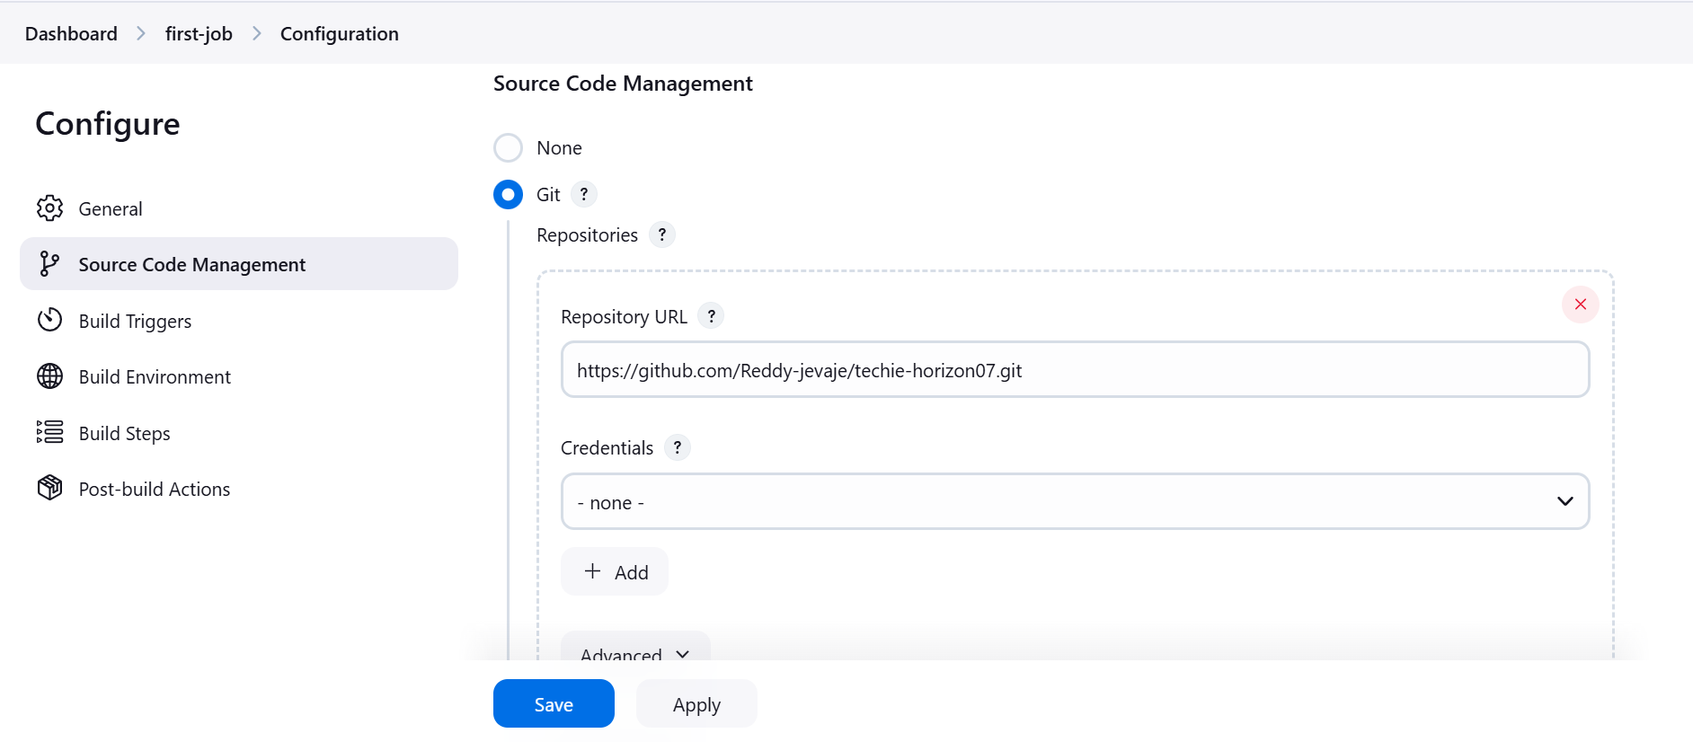

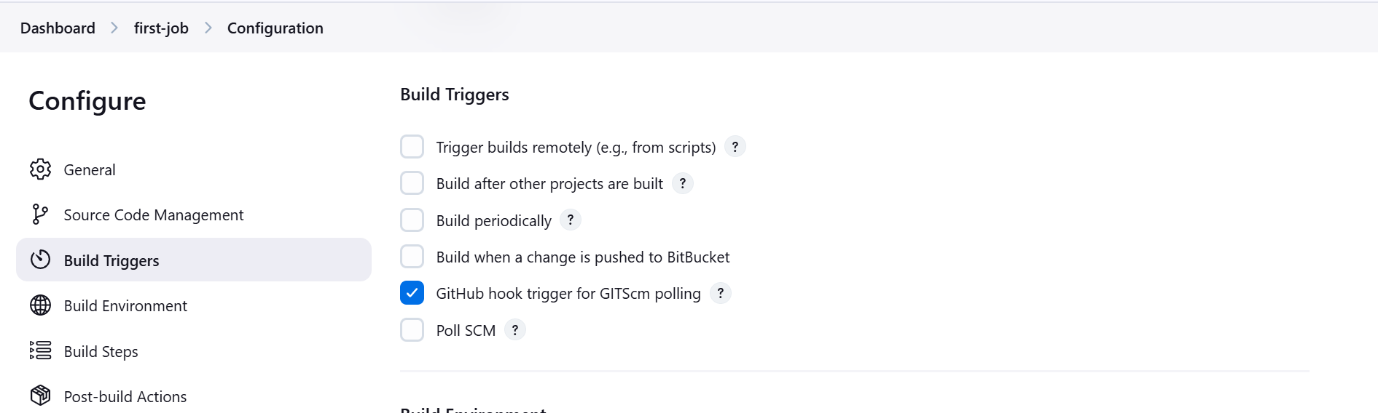

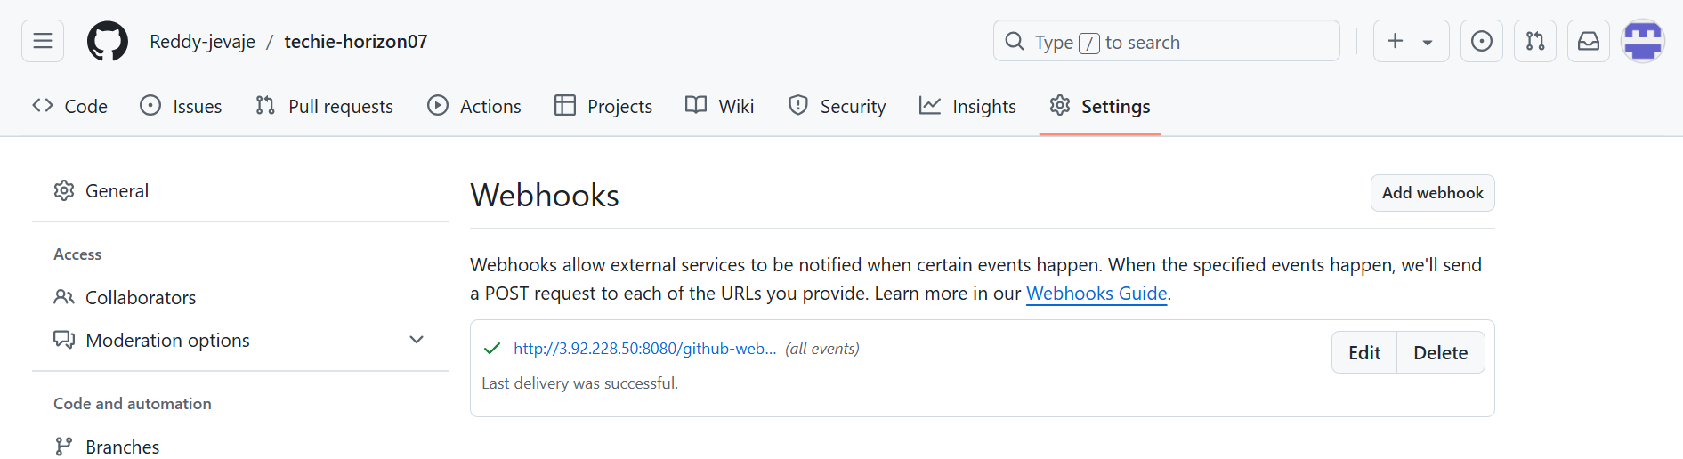

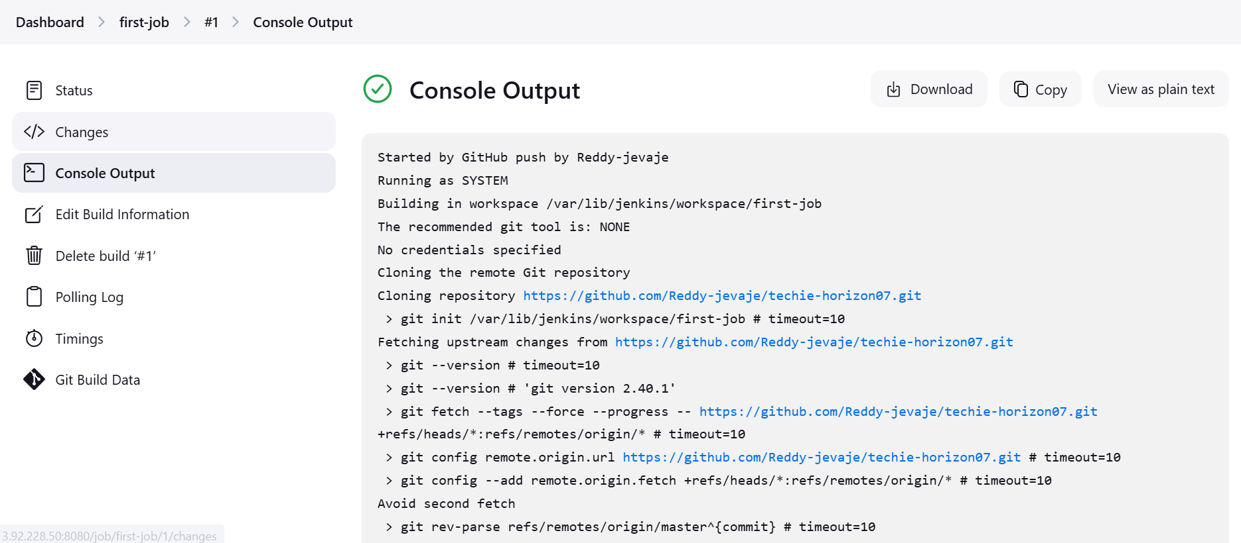

1. Configure poll scm and build periodical options in jenkins job.

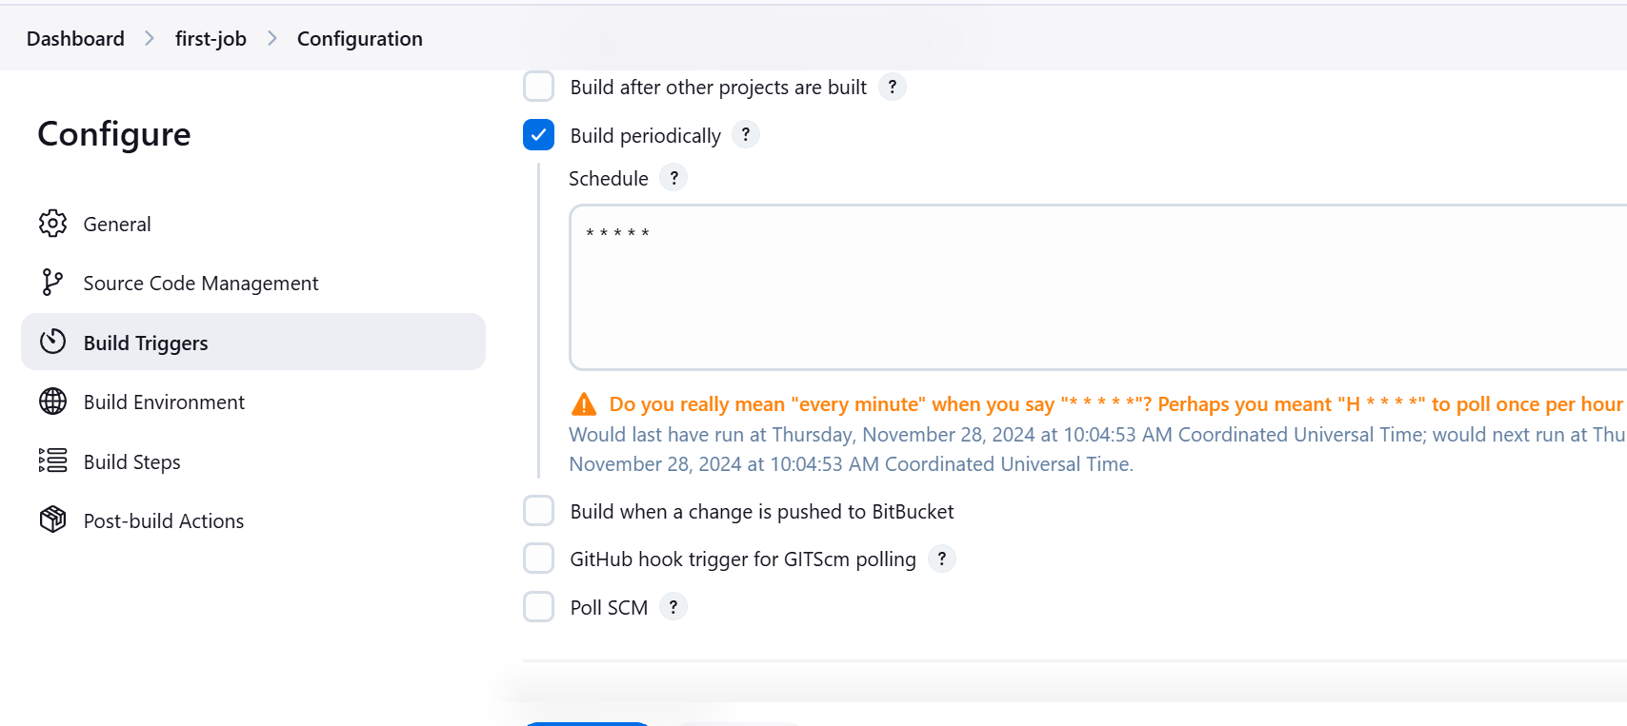

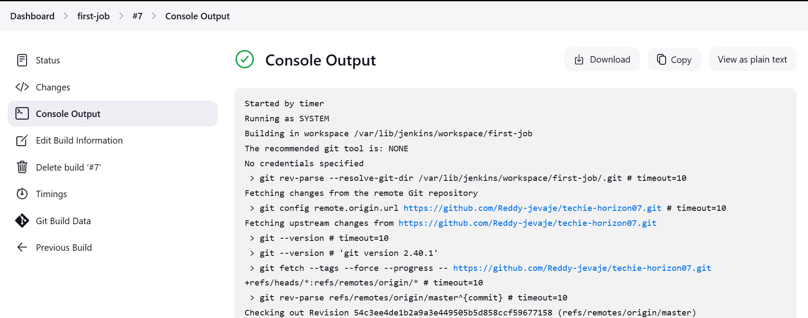

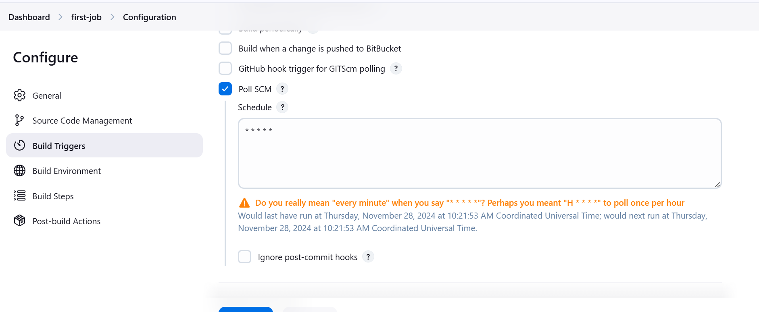

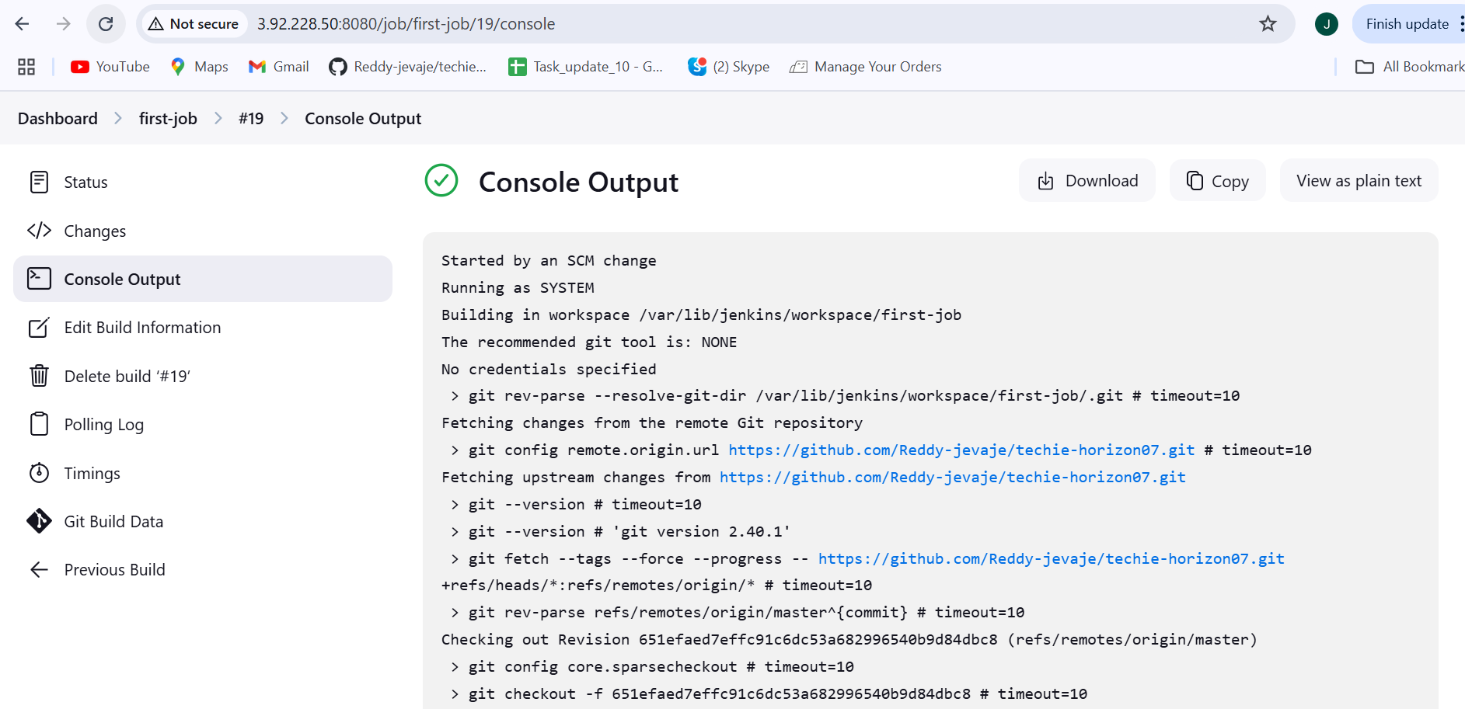

1. Take backup of jenkins server by using bash script.

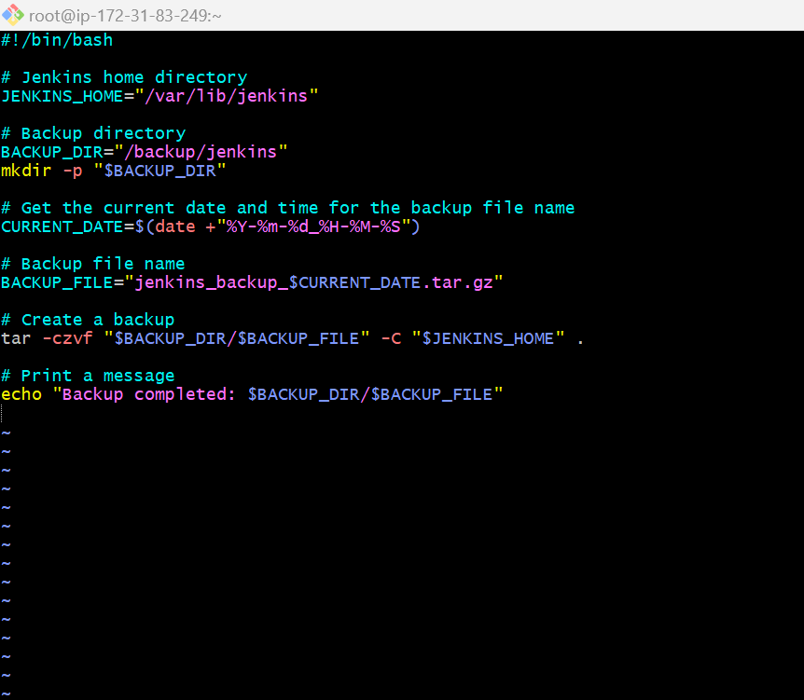

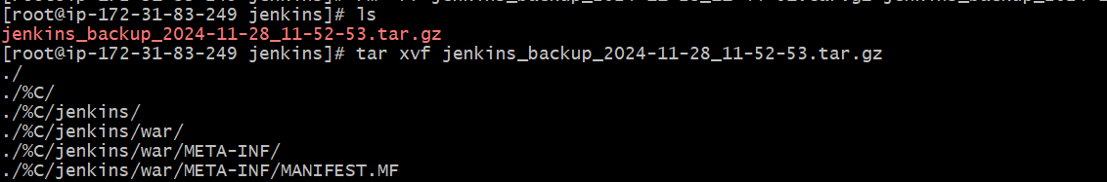

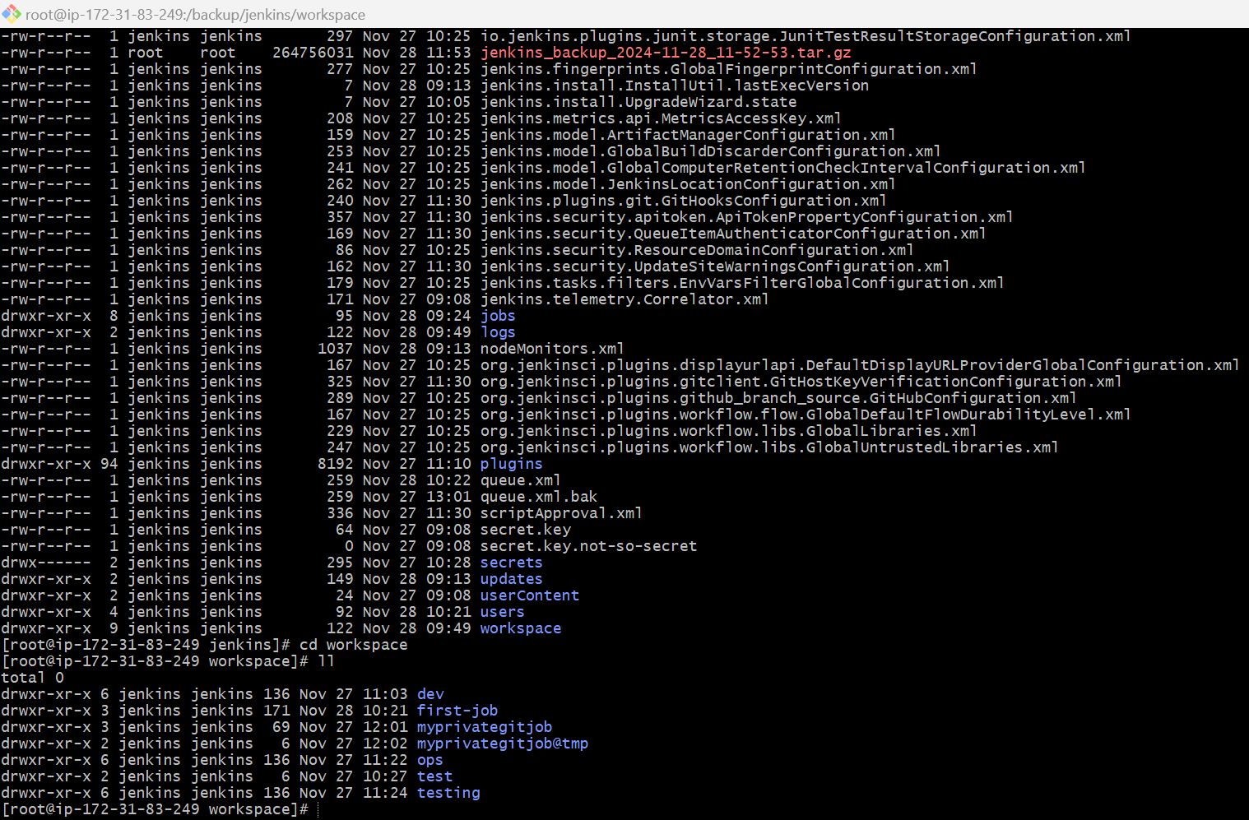

1. Take backup of jenkins using rethin backup plugin.
2. Setup a new jenkins server and dump the backup taken in task4.